# Python Code:

**from** operator **import** index

**import** numpy **as** np

**import** pandas **as** pd

**import** matplotlib.pyplot **as** plt

**import** matplotlib.dates **as** mdates

*# read data*

data = pd.read_csv('gantt chart data.csv')

*# print data*

**print**(data)

*# drawing gantt chart*

n = len(data)

plt.figure(num=1, figsize=[10, 5], dpi= 100)

bar_width = 0.9

**for** i **in** range(n):

i_rev = n - i - 1

*# plotting the last task first*

plt.broken_barh([(data["Start"][i_rev], data["Duration"][i_rev])], (i - bar_width / 2, bar_width), color="c")

plt.broken_barh([(data["Start"][0], data["PastTime"][i_rev])], (i - bar_width / 2, bar_width), color="w")

y_pos = np.arange(n)

plt.yticks(y_pos, labels=reversed(data["Activity"]))

*# xticks*

plt.gca().xaxis.set_major_locator(mdates.DayLocator())

*# grid*

plt.grid(axis="x", which="major", lw=1)

*# finishing touch*

plt.xlim(data["Start"][0])

plt.xlabel("**\n**Days", fontsize = 12, weight = "bold", style = "italic")

plt.ylabel("Activity**\n**", fontsize = 12, weight = "bold", style = "italic")

plt.title("Gantt Chart**\n**", fontsize = 16, weight = "bold")

plt.tight_layout(pad=2)

*# plot graph*

plt.show()

# Terminal:

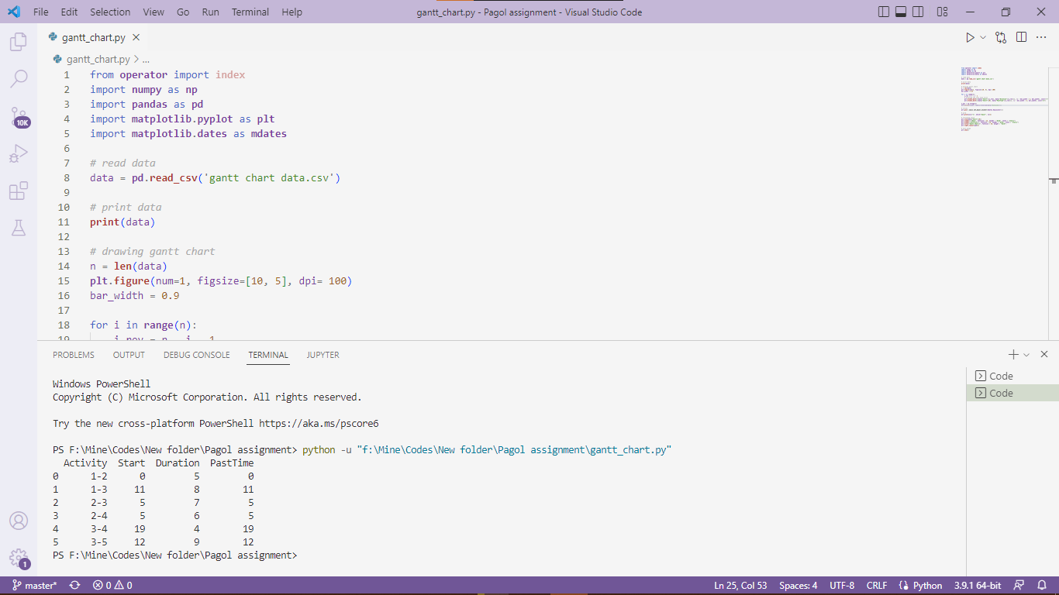

# Output:

